 

A.O.K. Laptop System Overhaul

Course Project: IS 436 Structured Systems Analysis and Design

Deliverable 5 –– “Closing: User Interface Design, Program design and System Implementation”

12/04/2019

Team Name: Meticulous Evolution Consulting

Project Sponsor: Library Services Manager, Paula Langley.

Presented By:

|  |  |  |
| --- | --- | --- |
| **NAME** | **POSITION** | **CONTACT** |
| Upen Adhikari | Quality Assurance | [adh3@umbc.edu](mailto:adh3@umbc.edu) |
| Omar Al-Hedari | Project Manager | [Omara2@umbc.edu](mailto:Omara2@umbc.edu) |
| Nima Roomi | Lead Developer/Programmer | [nimar1@umbc.edu](mailto:nimar1@umbc.edu) |
| Alex Varghese | Database Administrator | [varghes1@umbc.edu](mailto:varghes1@umbc.edu) |
| Ralu Ofoche | Systems Analyst | [rofoche1@umbc.edu](mailto:rofoche1@umbc.edu) |

**Table of contents**

**User interface design prototypes 2**

**Interface Standards 7**

**Program Design 8**

**Hardware/Software Requirement 8,9**

**Team Experiences 9**

**Task Distribution 11**

**Detailed Project work Plan 12**

**User interface design prototypes**

**Home page**

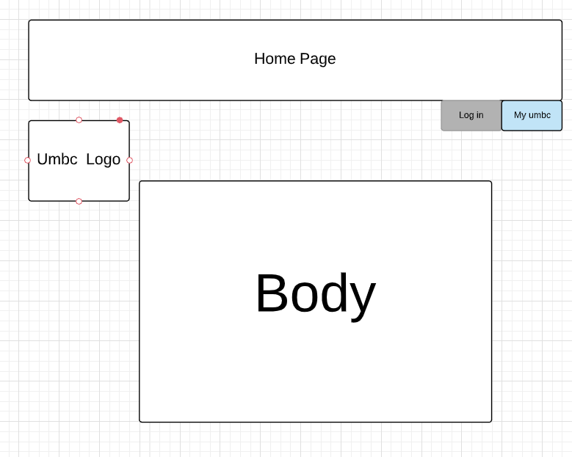

**Login page**

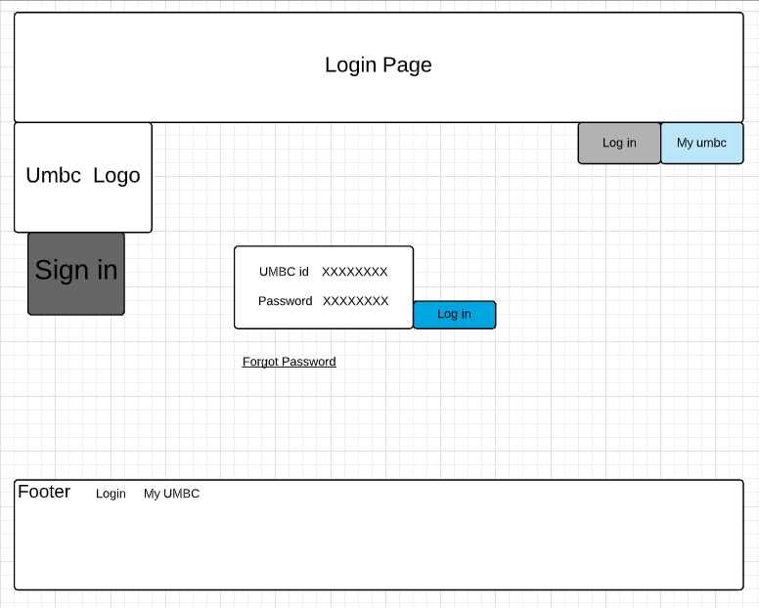

**Check in Page**

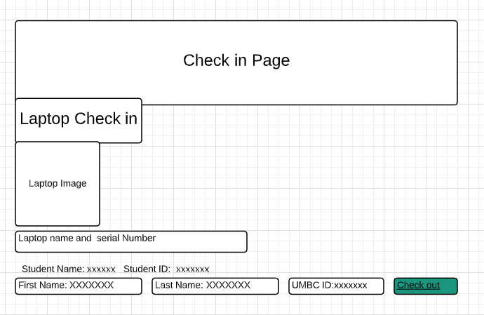

Renting Page:

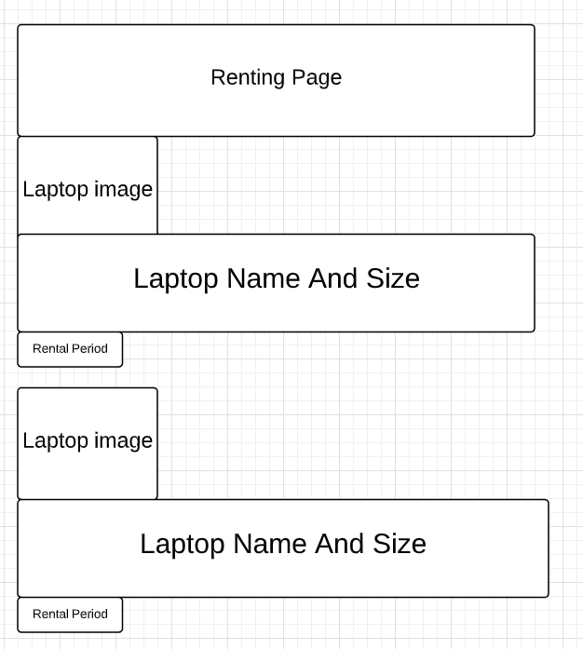

Staff Page

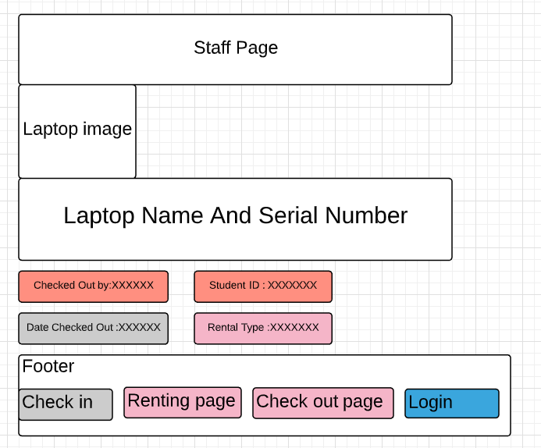

**Interface Standard**

**Interface objects**

Patron/customer: Requests laptop using the browser.

Staff: Accesses the laptop request made by the patron.

**Interface actions/Interface Icon:**

Request: Request of Laptop

Login: Login is required to access the service.

Check out : Check out of Laptop

Check in: Check in for loaning laptop

Return: Returning the loaned Laptop.

**Elements on the screen:**

Home: Home page of the screen

Student ID: It is required for loaning the laptop.

Login: Login is required to access the service.

Password: Password must be entered for login.

Name: Valid first and last name is required.

Laptop Name: Laptop name has to be entered.

Serial Number: Laptop is identified with the serial number.

Check out: Check out of Laptop

Check in: Check in for loaning laptop

Reservation: Holds reserved laptop

**Program Design**:

The static program is implemented in the design with multiple responsive pages. We designed our program from the prototype developed in the wireframe diagram. The design of this page was designed for simplicity and efficiency. The main issue seen on the web portals for online services is too much effort was placed in making it “look pretty.” Embellishments require vast knowledge of the programming language that many individuals do not possess on hand. This is the same issue that is present in the current website. The AOK Library only had one individual who was proficient in PHP to understand how to update the available information for students worked i.e. available laptops. When said individual left the library, not a single entity knew how the code was to be maintained. This eventually led to the removal of this feature and disrupted the process. The new UMBC Mobile print website design inspired the design with it’s simplistic design and ease of use.

**Hardware Software requirement:**

**Hardware:**

* Xeon 28 core processor
* 6 TB Disk Drive
* 1 TB of disk space
* 64 GB RAM

**Software:**

* MY SQL
* Windows,Linux,Mac OS

**Database:**

* SQL server 2012
* Microsoft SQL

**Server:**

* Dual 1000 Mbps Ethernet

**Team Experience/ Challenges:**

The fruition of this project was sweet after being sour for most of the deliverables that was overcome as a team. As a group, a member of the team kept the momentum of the group going forward on deliverable 3 all the way to deliverable 5 making that member an asset on delivering every time when needed. The challenges were that members had other obligations for other classes like all of us do and had to balance it out with the deliverables for the class. The background that the group brought to the table for the project is really diverse but was almost the primary reason for us struggling to agree on what is needed to be done for each requirement for all the deliverables.

During this project, the team had overcome major obstacles such as knowing exactly was is needed to be done for every single deliverable. Most of the challenges that the group had was being on the same page for the topic for the project. Members of the project had difficulty seeing the light at the end of the tunnel for the project. With the diversity of what we brought for this project we were able to find a way out for the project to deliver what is needed to be done.

With each phase of the project, confusion was very visible on getting concepts applied to the topic. Dealing with the library was very stressful because they are understaffed and was not really cooperating when needed for certain phases of the project. Even though a member of the group worked within the facility of the library, information given was inadequate in delivering what is needed for all the deliverables.

By each phase of the project, the complexity of the project was becoming hard to deliver and have the project

**Demo Link:**

[**https://rofoche1.github.io/AOKlibrary/**](https://rofoche1.github.io/AOKlibrary/)

**Repository Link:**

[**https://github.com/rofoche1/AOKlibrary**](https://github.com/rofoche1/AOKlibrary)

**Kanban Board: Task Distribution**



